## horizontal line

## 

**CodeCanvas**

**Week 3**

**Blender in Design**

**21 December 2023**

# Overview

Embark on a new dimension of creativity with Blender, the premier 3D design software revered across industries. Beyond the constraints of traditional 2D, Blender empowers you to craft immersive visuals for games, contribute to cinematic marvels, or sculpt detailed stills for various applications. Mastering Blender isn't just about skill acquisition; it's a strategic advantage, setting you apart from peers limited to two dimensions. With Blender, professionalism seamlessly meets a user-friendly interface, ushering you into a world where 3D design becomes an accessible and boundless realm for your artistic aspirations.

# Goals

**In this 3D journey, we will be learning the following things :**

* **Blender Basics, navigation through the software.**
* **Modeling your assets.**
* **Using modifiers to make your life easier.**
* **Adding Physics to Your Objects**
* **Adding materials and shaders to your model**
* **Lighting your scene**
* **Adding some Animation.**
* **Rendering your final output.**

# Getting Started

## Software Setup and Beginner Tips

* First, you will need to get Blender installed on your systems. The following link will provide you with the download link of the software: [Blender](https://www.blender.org/download/)
* Next, you would like to navigate through your software, which is very useful to learn or you will be stuck forever in that mess. Here’s a quick video lesson for you to learn navigation in Blender: [Blender Basics](https://www.youtube.com/playlist?list=PLa1F2ddGya_-UvuAqHAksYnB0qL9yWDO6) (videos 1-4)
* Next, you should learn how to add new objects to your scene. So here is another video lesson for that too: [Blender Basics](https://www.youtube.com/playlist?list=PLa1F2ddGya_-UvuAqHAksYnB0qL9yWDO6) (videos 5-7)

Rendering your Final Output

* Now you have created a great scene in your file but how do you show it to others? For that, you would need to export the Scene as a render.
* A render is nothing but just a still or moving export of your scene.
* You can learn how to render your scene through this video lesson: [Blender Basics](https://www.youtube.com/playlist?list=PLa1F2ddGya_-UvuAqHAksYnB0qL9yWDO6) (videos 23-27)

# Lessons

## Modeling in Blender

**Modeling** is the first and the most basic step that is present in the world of 3D. You create your assets using modeling. You can model using your imagination or using reference images that help make realistic models of objects. In this lesson, we will learn the basics of modeling and the know-how of the edit menu.

* First, we will **model a chair**, a chair is one of the most common things to start modeling with and can be a great starting point as it introduces you to some of the most helpful modifiers in blender. Learn to model the chair through this series: [Modeling a chair](https://www.youtube.com/playlist?list=PLjEaoINr3zgEL9UjPTLWQhLFAK7wVaRMR) (you only need to watch videos 1-6)
* While modeling this chair you will learn these concepts
  + Using the edit workspace and operations like, **extrude** and **loop cut.**
  + Using **modifiers** such as **subsurface division**, **bevel**, and **mirror tools.**

Your Submission for this lesson will be to submit a **.blend** file in which you have created a model of any of the following objects. These don't need to be exact replicas of the reference images. (No Need to add materials, it's just the workspace model we will be marking you on.)

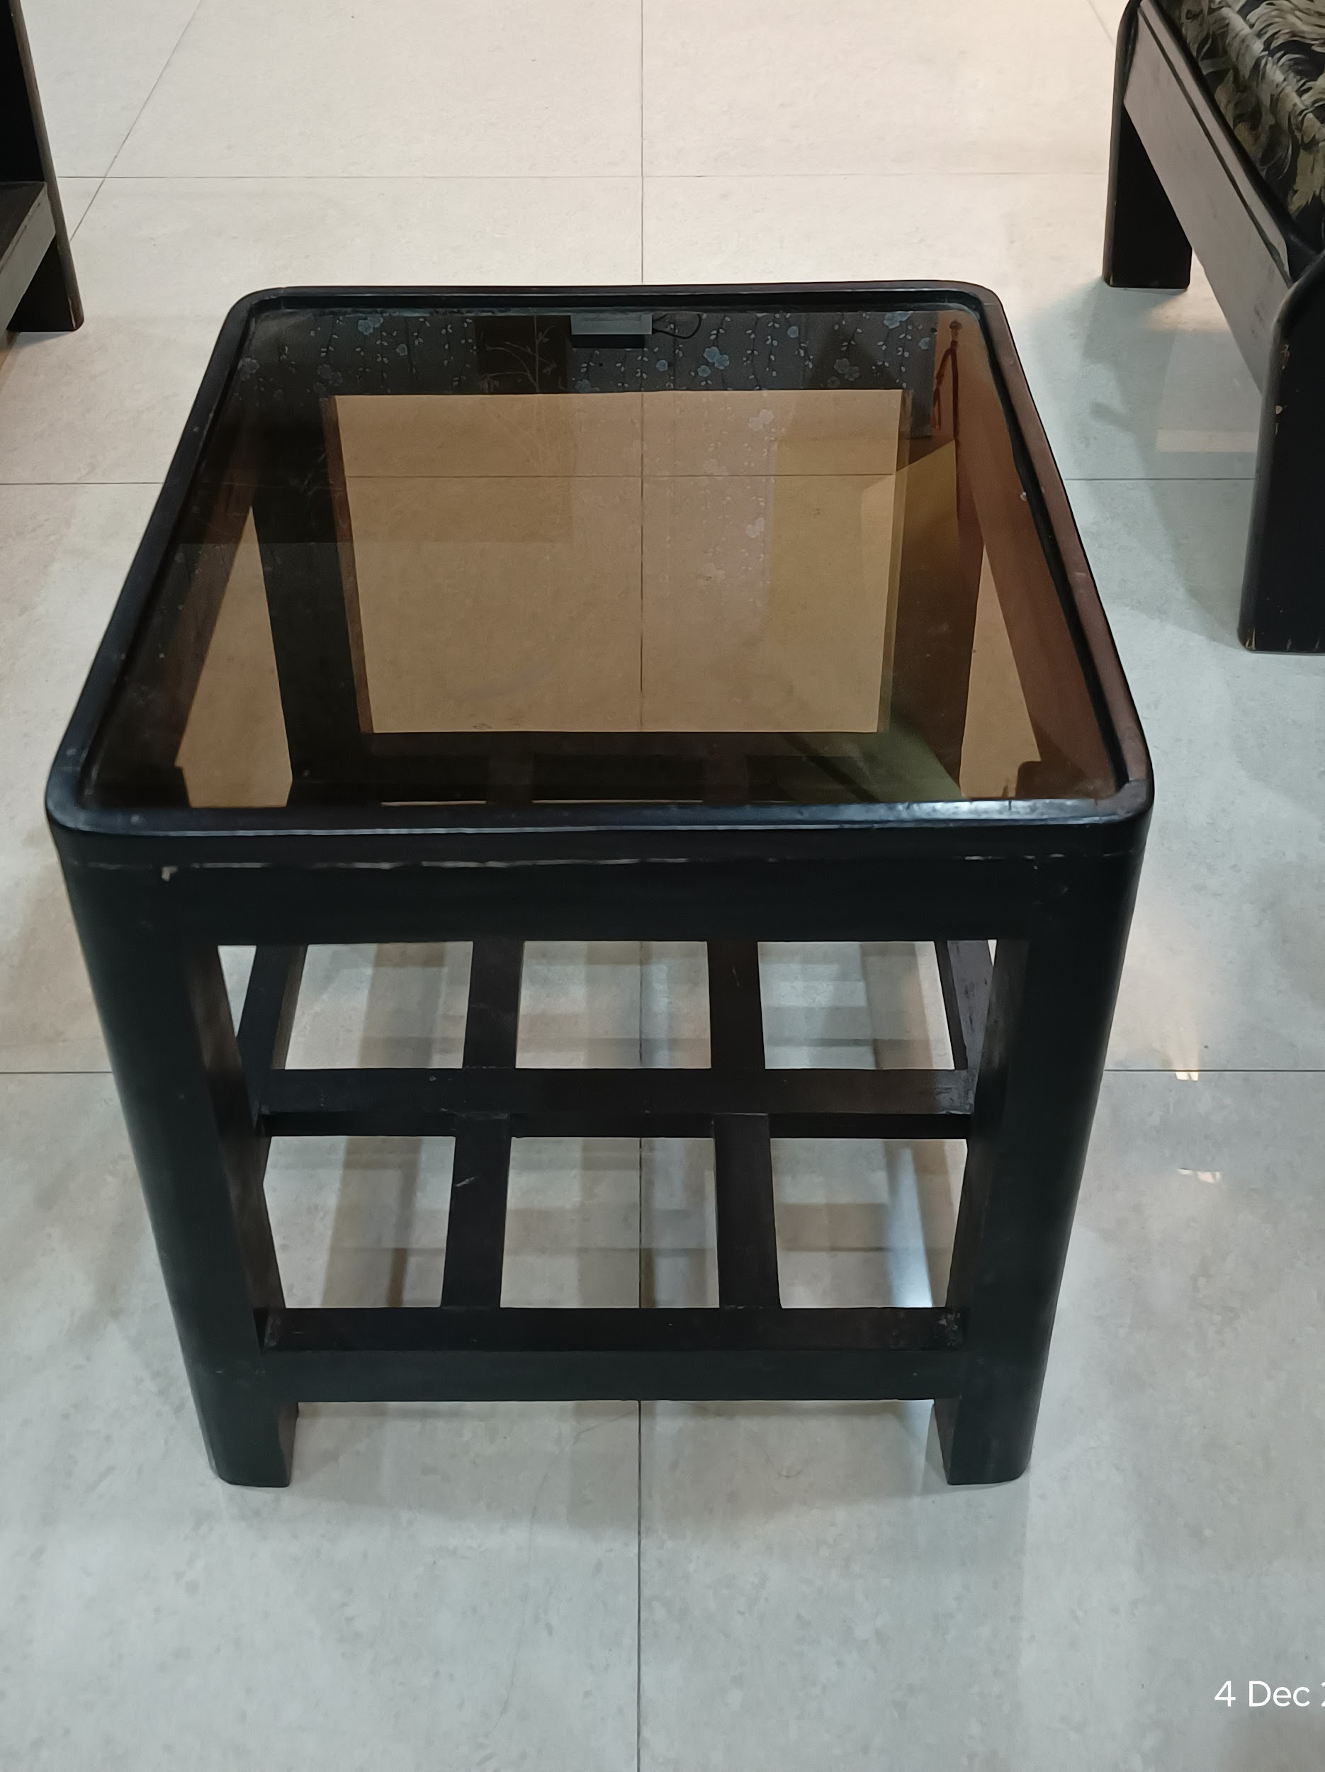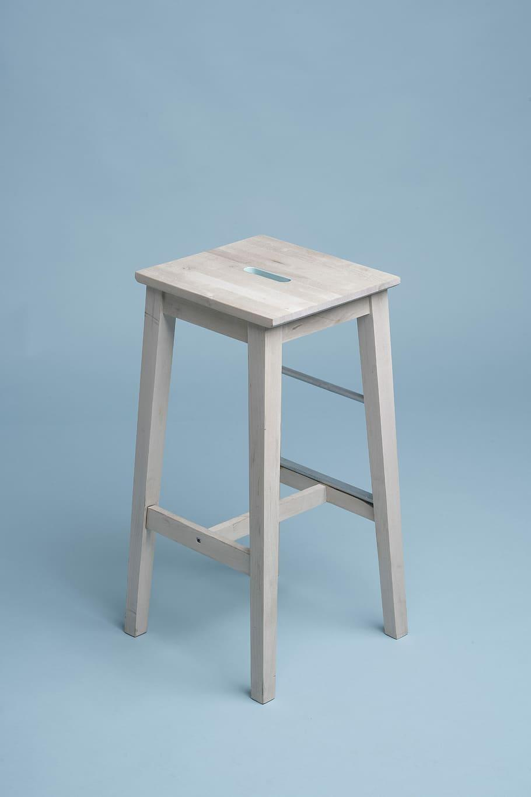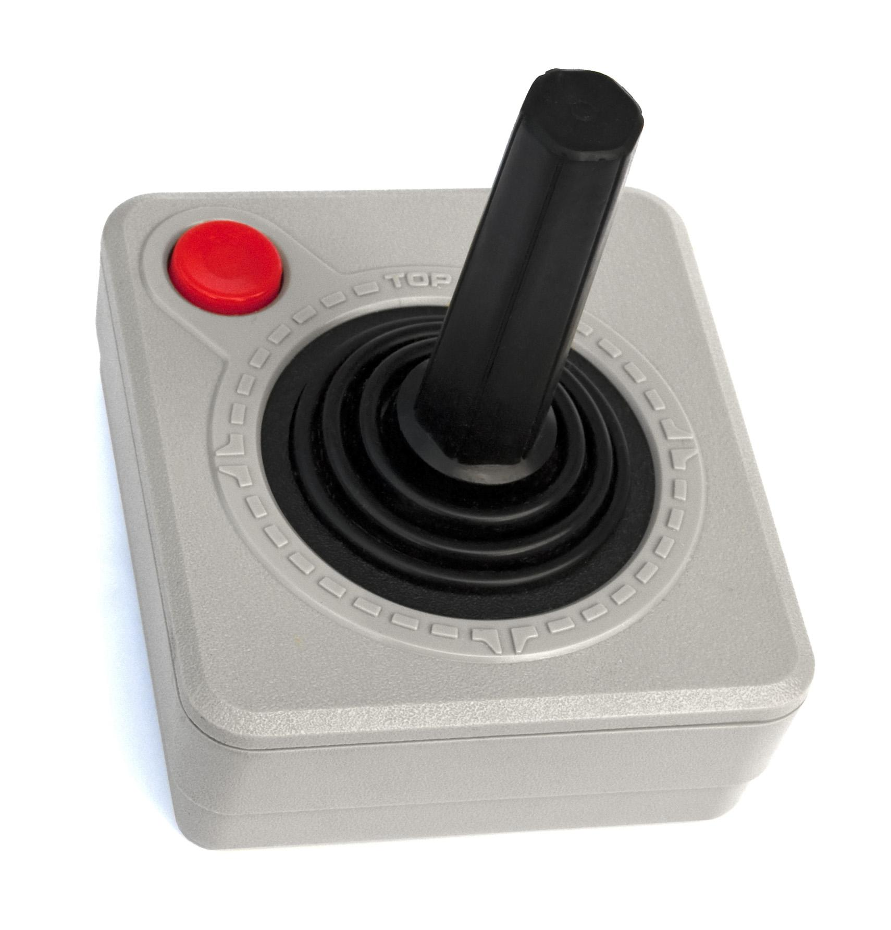

## Adding Materials and Shading

**Materials or shaders** are nothing much, just adding colors and texture to your model. This can be done in two ways :

* Using procedural textures
* Using images as textures.

In our lesson, we will be focusing on making a **procedural wood** texture for the **stool or the**

**glass top table** that you have made or plastic textures for the **joystick** you have made.

Making Procedural Wood Shaders: [Blender 3.0 Natural Wood Material In Under 2 Mins!](https://www.youtube.com/watch?v=Egd_BNAT3l8)

Making surface imperfections: [Blender- Surface Imperfections Tutorial (Procedural Shading)](https://youtu.be/67tWv6Hp_w0?si=jn0rm8C9tO4cAfsi)

You will have to submit your shaded models' **.blend** file here with all the shaders activated.

1. Lighting the Scene

**Lighting** is one of the most important things that you should learn to make amazing renders. It is the mood setter for the whole of the scene and can **drastically affect the impact** of your assets on the screen.

The most common way to light a model is to use **3-point** lighting in your scene and this helps when you are presenting a single model to someone. Otherwise, you can light your scene as you wish.

Adding lights in Blender: [Light Types - Blender 2.80 Fundamentals](https://youtu.be/FdbnzfjoOJU?si=jjYgdpiNCcC-xOpT)

Learn how to use 3-point lighting in Blender: [Three Point Lighting - Blender 2.80 Fundamentals](https://youtu.be/RDbrOpnIY7Q?si=dnNJJIoBdN8M5fyF)

In this lesson, you will have to **add lights to the scene provided** by us, such that the details of the model in the scene are visible.

**You can download the scene from here:**[**https://drive.google.com/file/d/1ympw8ySLccZhXKruNsxBNaPO2Xodwee1/view?usp=drive_link**](https://drive.google.com/file/d/1ympw8ySLccZhXKruNsxBNaPO2Xodwee1/view?usp=drive_link)

**Your submission must contain the .blend file with added lights and an exported scene image.**

The Final Showdown

Now you have learned all the basics for blender and are ready to embark on your 3D journey. But before you leap forward and jump into the vast world of blender a little practice won't be bad. With some practice, why don't we also learn some animation? You will be adding a little bit of animation in your renders and also exporting a video of it. You can learn keyframe animation from the following link: [Tutorial: Blender Keyframes For Beginners](https://www.youtube.com/watch?v=8gi9lUYMRcI)

So for your final submission, you will have to make the following :

* A model of a water bottle ( choose a bottle that has a somewhat low level of detail)
* Add materials to it.
* Add proper lighting to the scene.
* Animation to the bottle as per your liking.
* Export the scene as a **.jpeg** image.
* Also, export a video showcasing your animation.

In your submission, you will have to submit the **.blend** file, the exported image for the scene

# Resources

These are the resources that you will need to learn some of the basics of the software and we have also added a few of our special links where we go for inspiration and also to learn.

Download Blender: [Blender](https://www.blender.org/download/)

Tutorials to learn the basics of blender: [Blender Basics](https://www.youtube.com/playlist?list=PLa1F2ddGya_-UvuAqHAksYnB0qL9yWDO6)

(watch videos 1-7 to start understanding navigation in Blender)

Learning to model a chair: [Modeling a chair](https://www.youtube.com/playlist?list=PLjEaoINr3zgEL9UjPTLWQhLFAK7wVaRMR)

Making procedural textures: [Blender 3.0 Natural Wood Material In Under 2 Mins!](https://www.youtube.com/watch?v=Egd_BNAT3l8)

Making surface Imperfections: [Blender- Surface Imperfections Tutorial (Procedural Shading)](https://youtu.be/67tWv6Hp_w0?si=jn0rm8C9tO4cAfsi)

Adding lights in Blender: [Light Types - Blender 2.80 Fundamentals](https://youtu.be/FdbnzfjoOJU?si=jjYgdpiNCcC-xOpT)

Adding 3-point lighting: [Three Point Lighting - Blender 2.80 Fundamentals](https://youtu.be/RDbrOpnIY7Q?si=dnNJJIoBdN8M5fyF)

Keyframe Animation: [Tutorial: Blender Keyframes For Beginners](https://www.youtube.com/watch?v=8gi9lUYMRcI)

Rendering your image: [Blender Basics](https://www.youtube.com/playlist?list=PLa1F2ddGya_-UvuAqHAksYnB0qL9yWDO6)

(watch videos 23- 27 to understand rendering in Blender )

# Submission

You will have to submit all the necessary files in the asked formats under each of the sections in the form of a **Google Drive folder**. These should contain all the **.blend files**, the **exported images**, and any other assets that you may have used.

A **Google form** will be shared with you through email where you will be submitting your creations